Assessment IV
Algorithms and Flowcharts
Nisanth S
ID: 12576

Questions:

1. Library Book Checkout: Write an algorithm and draw a flowchart for checking out a book from a library system.

Algorithms:

1. Start.
2. Log in:
2.1 IF existing member, Log in to the library system.
2.2 ELSE: 2.2.1 Get user details
2.2.2 Create Account.
3. Get Book_details.
4. Search for book.
5. Select Book.
6. Check Availability:
6.1 IF available, then go to step 7.
6.2 ELSE, go to step 4.
7. Redirect to Checkout.
8. Get Date_of_return.
9. Review checkout request.
10. Submit Request and Await Approval.
11. IF Approved, then Confirm Approval and go to step 12.
ELSE go to step 7.
12. Stop.
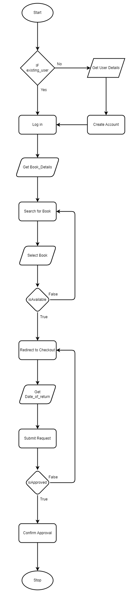
Flowchart:

2. Playing a Video: Write an algorithm and draw a flowchart for playing a video on a streaming platform.

Algorithm:

1. Start.
2. Log in:
2.1 IF existing member, Log in to the streaming platform.
2.2 ELSE: 2.2.1 Get user details
2.2.2 Create Account.
3. Get Video_details.
4. Search for Video.
5. Select Video.
6. Play Video.
6.1 IF Exit Platform, then go to step 7.
6.2 ELSE IF Select Different Video, go to step 3.
6.2 ELSE go to step 6.
7. Stop.
Flowchart:

